**INFO 6205**

**Program Structures & Algorithms**

**Fall 2020**

**Final Group project**

Junyao Li NUID:001050043,Yining Chen NUID: 001586646

**Introduction:**

A novel coronavirus (CoV) named ‘2019-nCoV’ or ‘2019 novel coronavirus’ or ‘COVID-19’ by the World Health Organization (WHO) is in charge of the current outbreak of pneumonia.

This project is aiming at simulating the spread of COVID-19. By using the k factor and R factor from resources scientific research resources, we could simulate how a pandemic will spread during a period.

We also develop distinct features such as wearing masks, participating in quarantines, and making social distance. Doing that, we aim to show people how can we flat the curve of COVID-19 spread.

**Project Details:**

We assume a city will have a population of 500 (500k), by making one person sick, this person will represent the first red circle in the UI. Whenever this person contacts another person, it will have a .9 possibility of infection. When a red circle collides with a green circle, there is a .9 possibility that the green circle will turn red. Also, we can see the difference when people put masks on, the possibility of getting infected would decline accordingly.

After getting sick for a period, their patient status will change to the next status (recover or dead). The mortality rate according to medical research is 0.66%, so a patient who recovered will change their color from red to blue, and those who are dead would become black.

**Mathematical Analysis:**

We use the below mathematical model to simulate our COVID-19 spread.

* Assumptions:

Assume the infected rate is constant;

Assume the recover/die rate is constant;

Assume the population remains constant;

* Definition of variables:

a= the rate that the person will be removed from the infected catalog

r= rate of contact = (1-k factor)

I=number of infected,

S=number of suspected populations.

rm=remove population

* Mathematical model:

1) The healthy population changing rate over time is -(1-k) IS

**ds/dt=-(1-k)IS\***

IS* means the contact between I and S

meaning whenever the Infected population and Healthy population having contact, there is a rate of 1-k that the person would get sick.

2) The population of infected changing rate over time is a*I

**dI/dt=(1-k)IS*-aI**

after certain sick time:

3) The population of death or recovery changing rate over time is a*I

**drm/dt=a*I**

we define the initial value of the infected population is 1 (patient zero)

and the rm population at the beginning is 0.

* Rates we use in the simulation:

With the assumption, we have constant populations S=200k in a city,

The infected rate r without masks 1-k1 factor 0.1; meaning an infected rate 0.9;

The infected rate r with wearing the mask is 1-k2 factor 0.6; meaning an infected rate 0.4;

the mortality rate which based on the research is 0.66%;

**Conclusion:**

**COVID-19 Spread simulation with rare protection:**

The original spread of Covid-19 virous indicates that this virous has a strong ability of infection. Without any protection and social distancing, the healthy population will be infected very quickly.

**

**SARS Spread simulation with rare protection:**

The screenshot indicates that SARS has less ability of infection, However, the mortality risk is higher than current Covid-19.

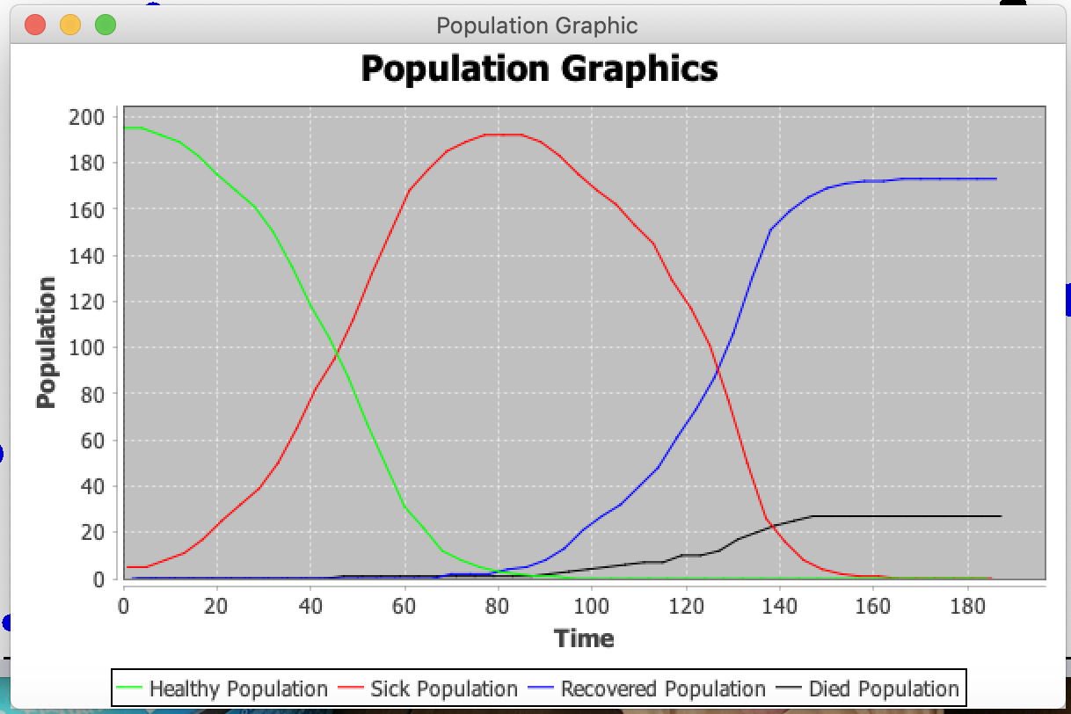

**COVID-19 Spread simulation with protection of masks social distancing:**

The screenshot shows the significant drop of infection rate while wearing masks and keeping social distancing.

**Quarantine during Covid-19:**

The screenshot shows how quarantine will keeping people from infection.

In brief, using the mathematical model along with the simulation program, this simulation indicates the importance of having protection during the period of COVID-19. Wearing masks, keeping social distances, and having quarantine would have a positive influence on slowing the infection.

**Screenshot of Unit test passing:**

personTest Unit test

CityTest Unit test

References:

1. <https://www.ncbi.nlm.nih.gov/pmc/articles/PMC7307707/>
2. <https://www.youtube.com/watch?v=NKMHhm2Zbkw>
3. <https://english.elpais.com/society/2020-10-30/the-k-factor-why-it-matters-where-we-are-infected-with-the-coronavirus.html>
4. <https://www.youtube.com/watch?v=cPVoEWtszag>
5. <https://www.youtube.com/watch?v=cw31L_OwX3A>